



TECNOLÓGICO NACIONAL DE MéXICO

INSTITUTO TECNOLóGICO DE SALTILLO



Arquitectura de Computadoras.

Práctica #3

Nombre de la práctica.

Memorias

Nombre del alumno.

HERNANDEZ GUILLERMO JHONATAN SMITH

Número de control.

19051141

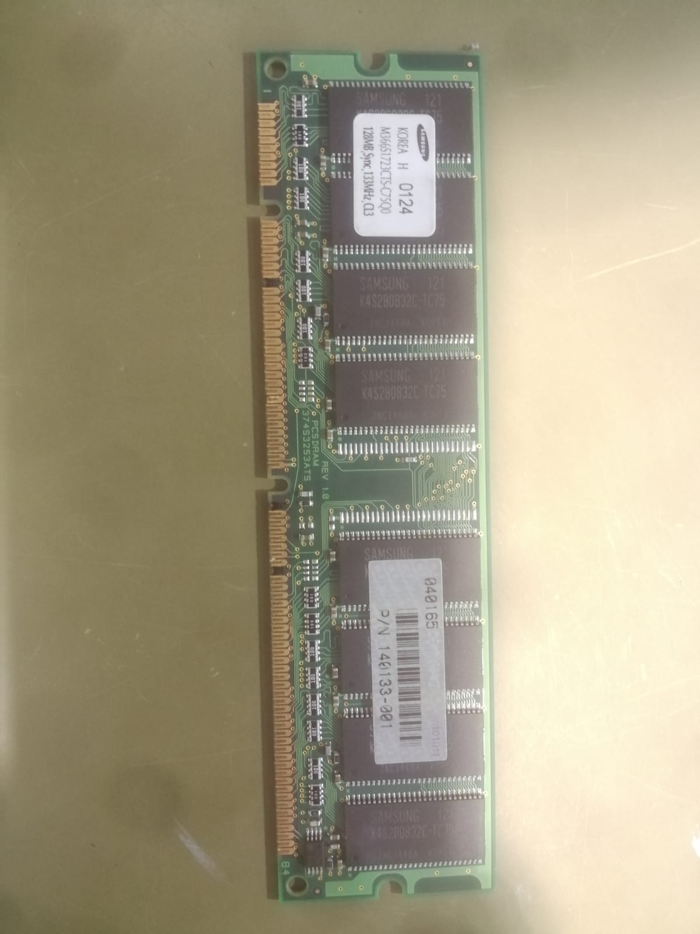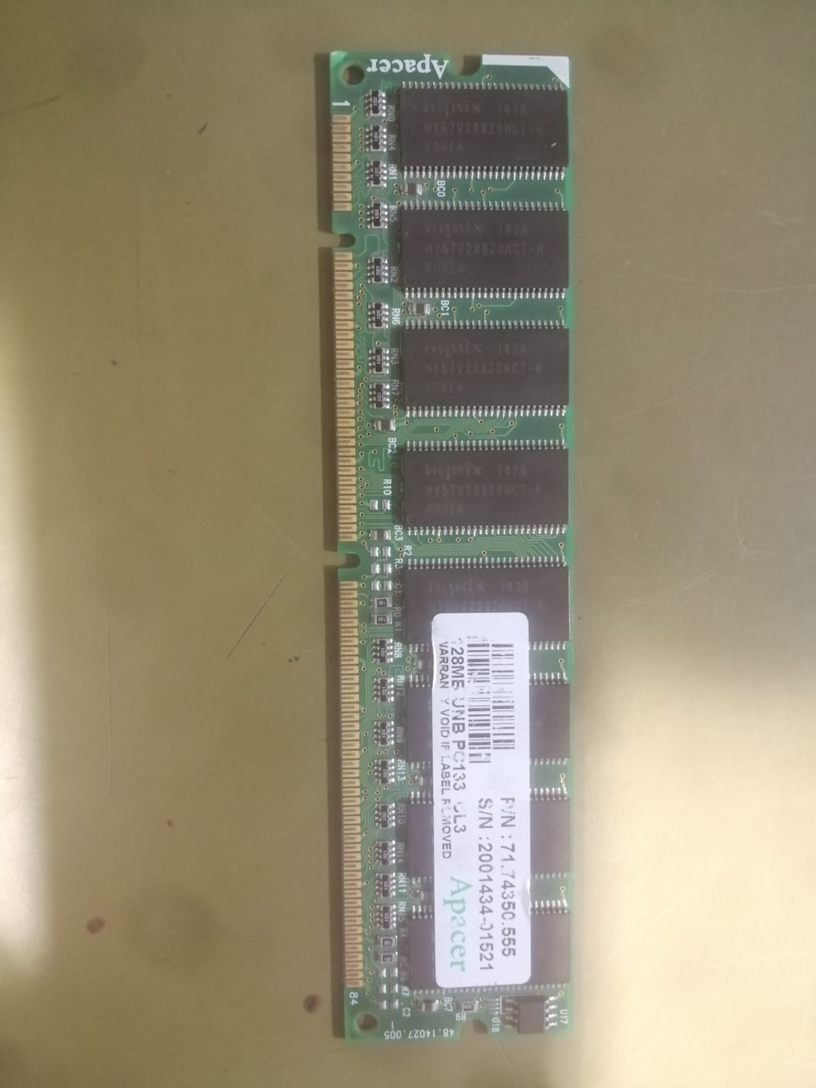

28MB SDRAM 133MHz Non-ECC Unbuffered DIMM

Código de artículo: KTC-EN133/128

SDRAM 133MHz Non-ECC Unbuffered DIMM CL3 3.3V 168-pin 400mil

Producto descatalogado

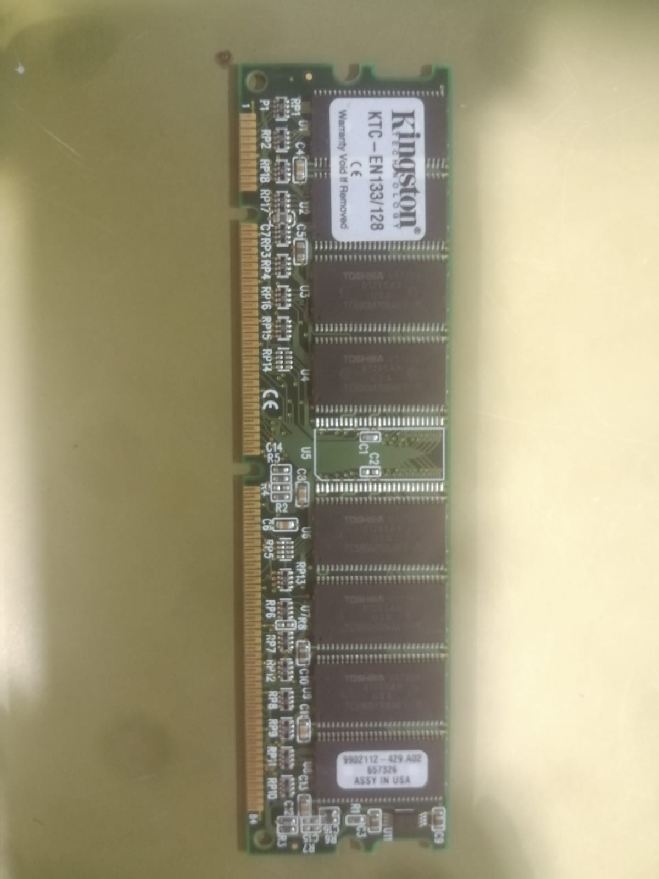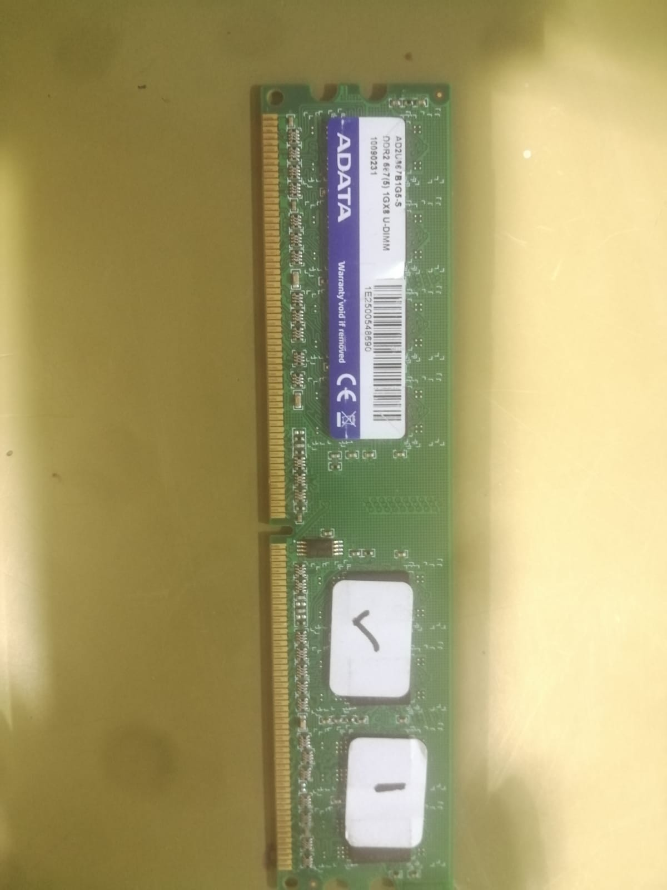

|  |  |
| --- | --- |
| **Marca** | OFFTEK |
| **Factor de forma** | DIMM 168-pin |
| **Tecnología de memoria RAM** | SDRAM |
| **Tamaño de la memoria de la computadora** | 128 MB |
| **Velocidad de memoria** | 133 MHz |

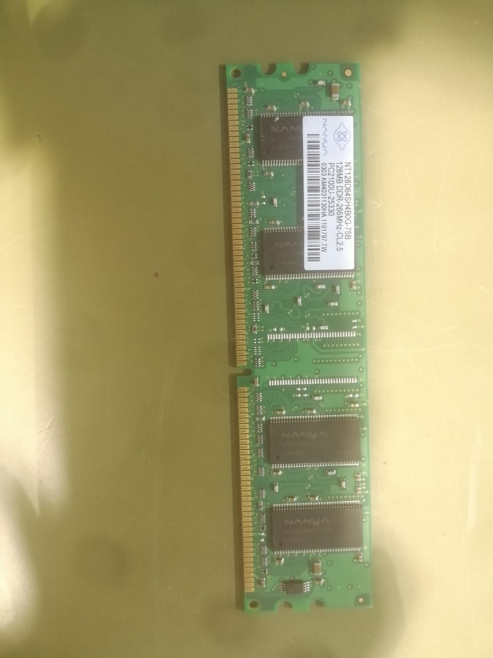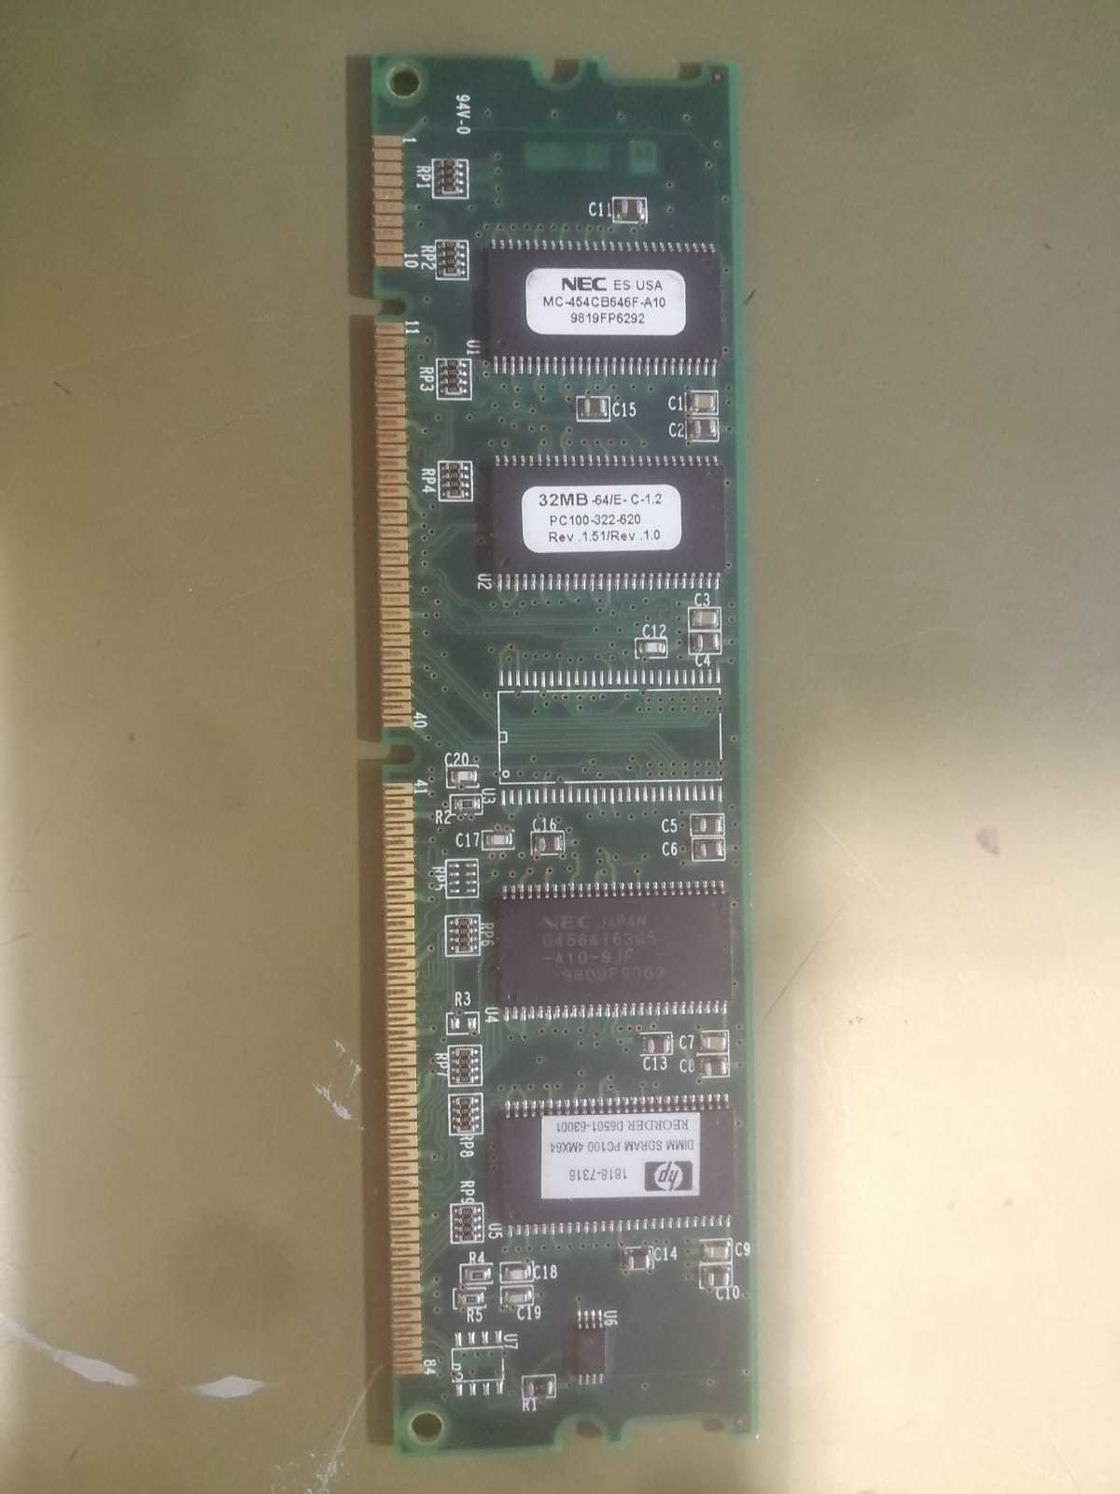

The RMLV3216A Series is a family of 32-Mbit static RAMs organized 2,097,152-word × 16-bit, fabricated by Renesas’s high-performance Advanced LPSRAM technologies. The RMLV3216A Series has realized higher density, higher performance and low power consumption. The RMLV3216A Series offers low power standby power dissipation; therefore, it is suitable for battery backup systems. It is offered in 48pin TSOP (I), 52pin μTSOP (II) or 48-ball fine pitch ball grid array.

Features

• Single 3V supply: 2.7V to 3.6V

• Access time: 55ns (max.)

• Current consumption: ── Standby: 0.6µA (typ.)

• Common data input and output ── Three state output

• Directly TTL compatible ── All inputs and outputs

• Battery backup operation